CO2-ASSIGNMENT 3
CSA0653 Design and Analysis of Algorithms for complex Problem
BY
Saimeera D(192524405)

Q1. Debugging Selection Sort (Incorrect Minimum Index Update)
Error Identification
Given Code
def selection_sort(arr):
n = len(arr)
for i in range(n):
min_idx = i
for j in range(i+1, n):
if arr[j] < arr[min_idx]:
min_idx = i # ERROR
arr[i], arr[min_idx] = arr[min_idx], arr[i]
return arr

Logical Error
The statement:
min_idx = i
inside the if block is incorrect.
It should be:
min_idx = j
Why is it Wrong?
When a smaller element is found, the algorithm should store its position (j) as the new minimum index.
Instead, the code repeatedly assigns:
min_idx = i
which keeps the minimum index unchanged.
As a result:
- The actual minimum element is never selected.
- Swapping occurs with the wrong index.
- The array remains partially or completely unsorted.

Corrected Code
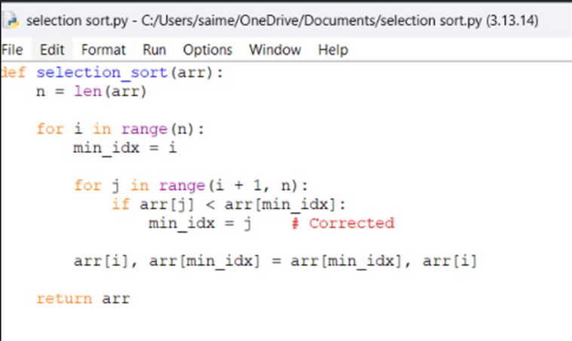

Example
Input
arr = [64, 25, 12, 22, 11]
Output
[11, 12, 22, 25, 64]

Time Complexity Analysis
Best Case
Even if the array is already sorted, Selection Sort still compares all elements.
[O(n^2)]
Average Case
[O(n^2)]
Worst Case
[O(n^2)]
Space Complexity
Only a few extra variables are used.
[O(1)]

Optimization
Avoid unnecessary swaps:
if min_idx != i:
arr[i], arr[min_idx] = arr[min_idx], arr[i]
This reduces unnecessary write operations.

Q2. Debugging Sequential String Matching
Error Identification
Given Code
def string_match(text, pattern):
n, m = len(text), len(pattern)
for i in range(n-m): # ERROR
j = 0
while j < m and text[i+j] == pattern[j]:
j += 1
if j == m:
return i
return -1

Logical Error
The loop:
for i in range(n-m):
does not check the last possible alignment.
It should be:
for i in range(n-m+1):
Why Some Alignments Are Skipped?
For a text of length n and pattern of length m:
Last valid starting position:
[n-m]
But Python's range(n-m) stops at:
[n-m-1]
Therefore, the last alignment is never checked.

Example
text = "ABCDE"
pattern = "DE"
Here,
n = 5
m = 2
Valid starting positions:
0, 1, 2, 3
But:
range(3)
produces:
0, 1, 2
Position 3 is skipped, so "DE" is never found.

Corrected Code

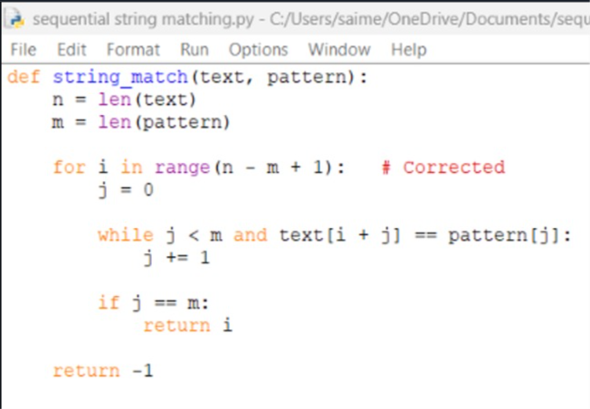

Example
Input
text = "HELLOWORLD"
pattern = "WORLD"
Output
5

Complexity Analysis
Worst-Case Time Complexity
For each position in the text, up to m characters may be compared.
[O((n-m+1)\times m)]
Approximately:
[O(nm)]
Best Case
Pattern mismatches immediately.
[O(n)]
Space Complexity
Only variables i, j, n, and m are used.

